**P5 Endangered Animals Project – Part 1**

The International Union for the Conservation of Nature’s Red List (IUCN Red List, states that there are 16,306 endangered species threatened with extinction.

Follow this link and choose the animal you want to focus on for your project.

<https://www.worldwildlife.org/species/directory?direction=desc&sort=extinction_status>

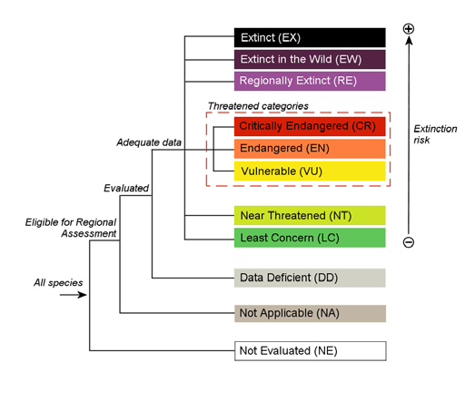

Once you have chosen your animal – check that it is critically endangered, endangered or vulnerable – it should be in one of these categories.

Your project should be at least 10 pages.

You should include.

An interesting Fact page about your animal.

A map showing where in the world your animal lives.

A page describing the habitat of your animal.

An explanation as to why this animal is important to our world.

A list of the THREATS to this animal.

An explanation as to what we are doing to protect this animal.

Illustrations throughout your project e.g., photographs, sketches

A contents page

A bibliography (A list of websites, books, magazines you have used for your information).

**The project can be done on paper, Powerpoint, Word or a combination of all.**

If you can it would be great if you could submitted on Friday 24th April.