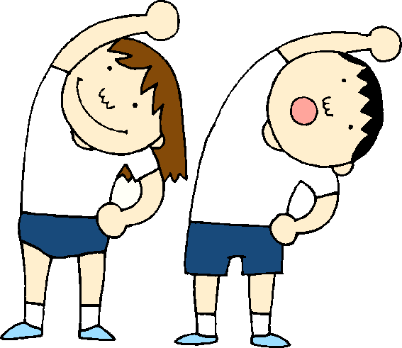Linlithgow Bridge Primary - PE at Home! First level

* Choose 2 activities each day to complete. Have Fun as you keep fit!

|  |  |  |
| --- | --- | --- |
| **Dance**  Can you dance along to these famous songs with Kids Bop?  Search Kids Bop Dance Along on Youtube.  Dance Monkey, Just Got Paid, Old Town Road | **Throwing** – overarm  Use some balled up socks to practices throwing accurately. Can you throw them into different sized boxes or at soft toy targets? | **Balancing**  Balances can be made on different parts of our body. Can you create and hold different balances?  Can you squeeze your muscles and stay still like a statue? Can you hold your balance for 5 seconds? |
| **Rolling**  Use some balled up socks to practice your rolling and accuracy. Use some items from your recycling bin. Try to knock them over by rolling you balled socks at them.  Step back further to challenge yourself. | **Fitness**  Joe Wicks is hosting a LIVE PE lesson every morning at 9am on his YouTube Channel.  Can you keep up with him? Have some drinking water ready! | **Running**  If you have a garden, could you teach some of your family one of our PE games?  Toilet tig, Shape Tig, Traffic Lights |
| **Catching**  Use your balled up socks to practice catching. Can you throw them up and catch with two hands. Can you throw, clap and catch? Can you catch when someone else throws it to you? Can you create your own catching challenge? | **Yoga**  This a great way to help you focus, be calm, keep flexible and have fun. Search for ‘Cosmic Kids’ on Youtube or find Frozen Yoga, Star Wars Yoga | **Be Creative**  Check with any adult about safe obstacles to use (recycled items, soft toys, a chair or table) to create an obstacle course. Think about different ways of traveling through or around it – hop scotch steps, crawling, sliding? |