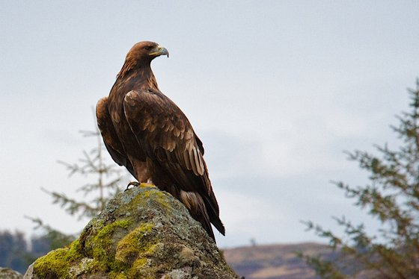**Scotland’s Golden Eagle Comprehension**

**Golden Eagles**

The golden eagle is the top predator in the Scottish countryside; it is a massive bird of prey that mainly hunts rabbits and mountain hares but will also catch foxes, young deer and large birds like grouse.

**Spotting a Golden Eagle**

Golden Eagles can be seen soaring high in the sky in upland areas and remote glens in the north and west of Scotland. Golden eagles nest on rocky cliff faces and in trees where they build a giant nest. These nests are often used by future generations to rear their own young. Golden eagles pair for life.

**Behaviour**

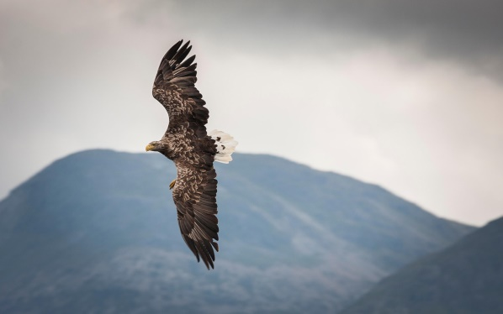A massive bird of prey, the golden eagle’s wings and tail are only a little smaller than the rarer white-tailed eagle. Adults are mainly dark brown, with a golden head and neck. Young birds have white patches in their wings and a white base to the tail.

**Size**

Golden Eagles are between 76cm - 90cm in length and have a wingspan of just over 2 metres. They can weigh between 3.5 kg – 5.3 kg and can live up to 23 years.

**Status**

Golden Eagles were often killed or poisoned because farmers were worried about them stealing their animals. Golden Eagles are now very rare birds so it is important we do all we can to protect them. Golden Eagles are now protected by law in the in the UK.

Please answer the following questions in full sentences.

If you can either complete in a Word document of take a photo of your work and upload onto Teams.

1. Write down one important detail about a Golden Eagle.
2. In your own words write down two facts you have learned from reading this text.
3. Who might be interested in reading this text and why?
4. Do the pictures help you to understand the text better? Explain your answer.
5. Explain in your own words why the Golden Eagle is now a rare sighting in Scotland?
6. Come up with a different title for this text. Explain why you have chosen it.