**Rights Respecting Schools**

The RRS Committee would like to thank everyone who participated in the ‘Spotacular

’ event for Children In Need. We are delighted to inform you that LBPS raised £93.00. Well done everyone! Following on from the success of this and our Harvest Foodbank collection the RRS Committee have decided to hold another event on Friday 16th December. More information will be sent home via group call, TEAMS and SeeSaw.

**Article of the Month**

At our assembly on the 11th November, the RRS Committee shared information about the ABCDE’s of Rights, as well as their new initiative of Article of the Month. November saw LBPS focussing on Article 38, Protection in War. The focus for December is Article 14, Freedom of Thought and Religion.

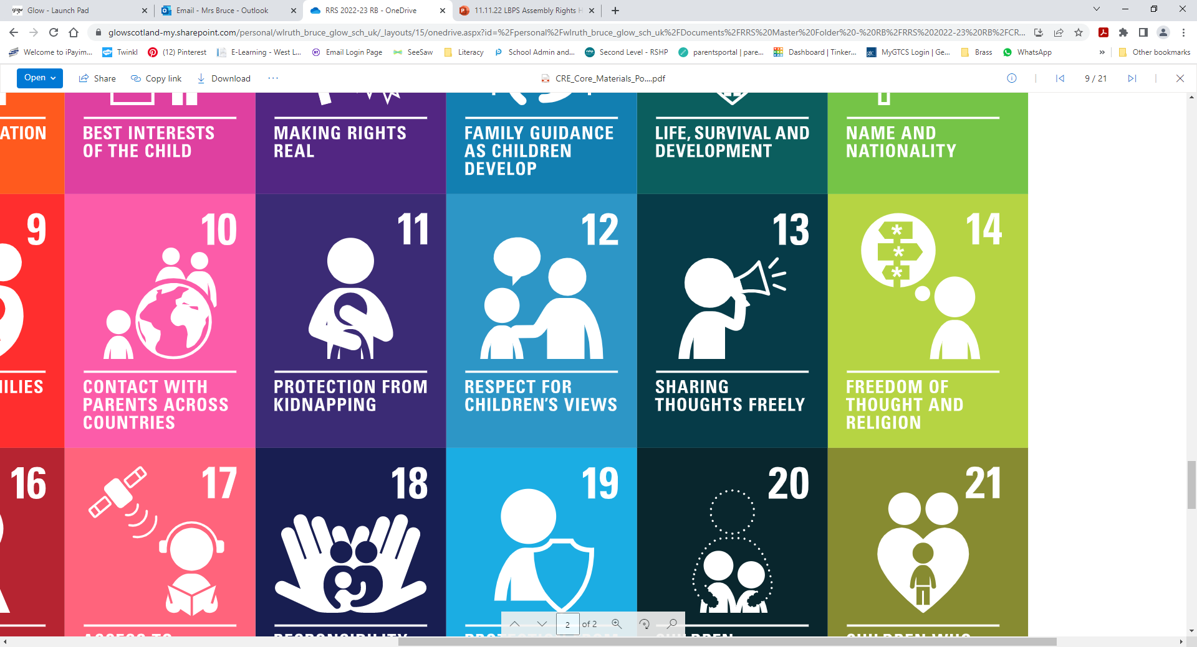

**Community Link**

As part of our wider community link, the whole school have created Christmas decorations for the Festival of Christmas Trees event at St Michael’s Parish Church, Friday 2nd December – Sunday 4th December. The theme this year is, Past, Present and Future, which linked nicely to our 20th Anniversary celebration.

